 Faith Supplement

Discover America- Course 18

**Fulton’s Steamboat**

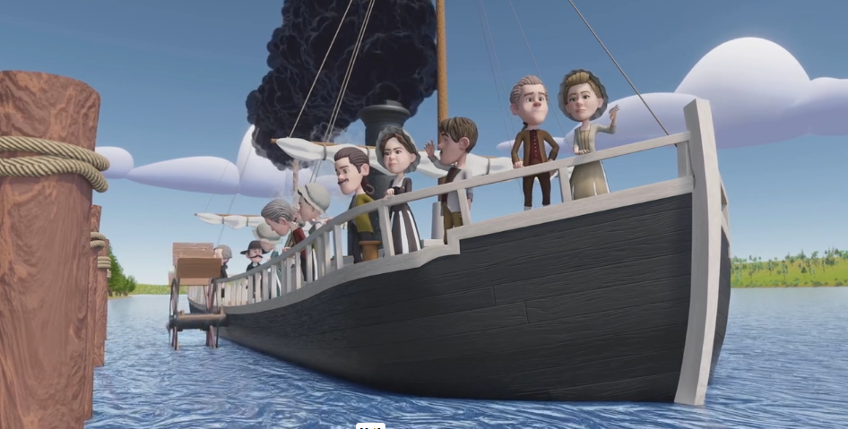www.littlepatriotslearning.com

Fulton’s Steamboat- Course 18

**MEMORY VERSE**

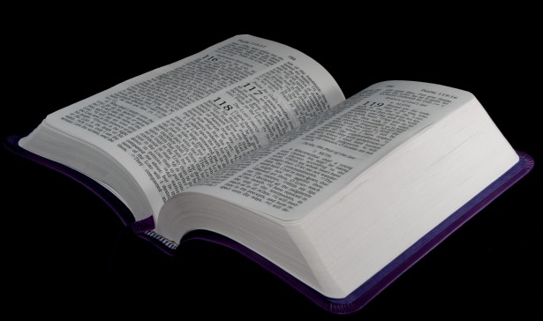

Daniel 2:20-23 (NIV):

20 And [Daniel] said: “Praise be to the name of God for ever and ever;

wisdom and power are his. 21 He changes times and seasons; He deposes kings and raises up others. He gives wisdom to the wise and knowledge to the discerning. 22 He reveals deep and hidden things; He knows what lies in darkness, and light dwells with him. 23 **I thank and praise you, God of my ancestors: You have given me wisdom and power, you have made known to me what we asked of you, you have made known to us the dream of the king.”**

Fulton’s Steamboat- Course 18

**FAITH FACTS**

* It is important to remember that wisdom and power come from God. Everyone needs knowledge from God to be creative and overcome obstacles. With God’s knowledge, you can creatively grow, change, and improve your community.
* When Daniel was asked to give the King Of Babylon guidance, he sought wisdom, answers, and advice from God.
* When it comes to problem-solving and being creative, it is essential to seek God's wisdom in the decision-making and creative processes.

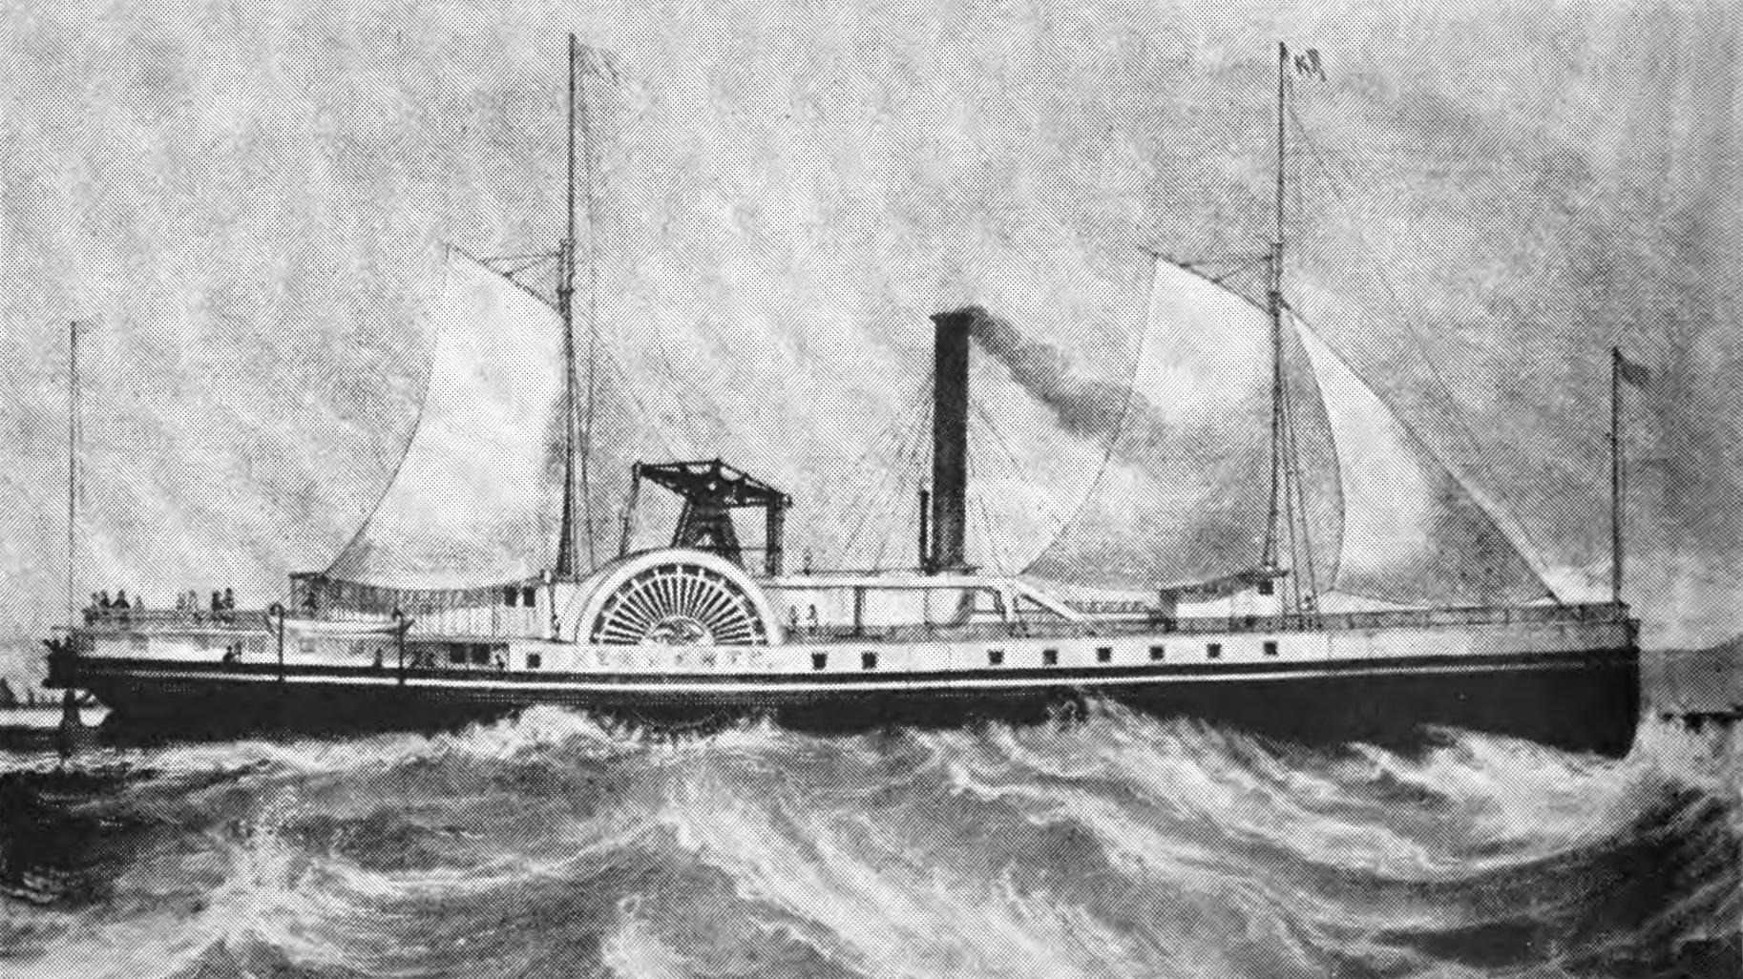

Fulton’s Steamboat- Course 18

**Memory Verse Cards**

|  |
| --- |
| *“***To Thee, O God of my fathers,**  **I give thanks and praise,**  **For Thou hast given wisdom and power.”**  -Daniel 2:23 |

|  |
| --- |
| *“***To Thee, O God of my fathers,**  **I give thanks and praise,**  **For Thou hast given wisdom and power.”**  -Daniel 2:23 |

Fulton’s Steamboat- Course 18

**Activity**

Embracing Wisdom and Power from the Lord!

|  |
| --- |
| Describe a time when you asked God to supply your needs and he did. Explain how He gave you the wisdom and power to overcome your obstacles.  ________________________________________________________________________________  ________________________________________________________________________________  ________________________________________________________________________________  ________________________________________________________________________________  ________________________________________________________________________________  ________________________________________________________________________________  ________________________________________________________________________________  ________________________________________________________________________________  ________________________________________________________________________________  ________________________________________________________________________________ |