***Kindergarten***

**DISCOVER AMERICA**

Course 18 - Teacher Guide

<add text overlay: Fulton’s Steamboat to image>

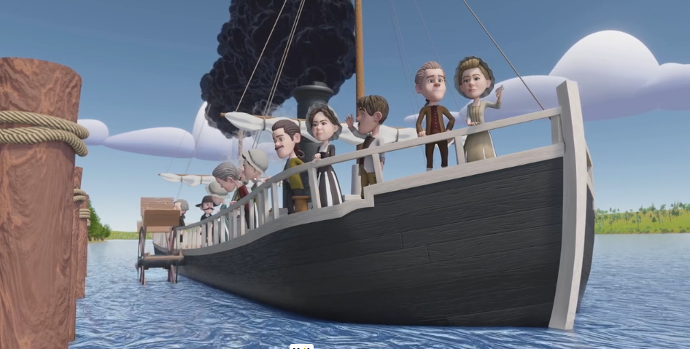

# Table of

# **Contents**

# 3 **Themes & Values**

# 4 **Learning Objectives**

# 5 **Introduction**

# 6 **Biography Study**

7 **Clermont’s First Voyage**

# 8 **Vocabulary Picture Cards**

# 9 **Worksheet**

10 **Resources**

12 **Notes**

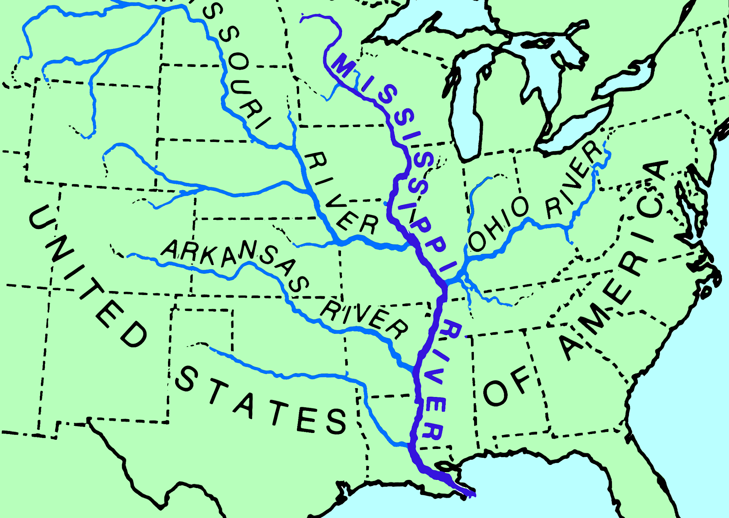

Kindergarten

# **Teacher Guide**

# **Key Themes**

* Creativity
* Community

# **Core Values**

* Community
* Liberty

# 

# **Learning Objectives**

# **Students will be able to:**

* Define creativity.
* Explain how the steamboat was created.

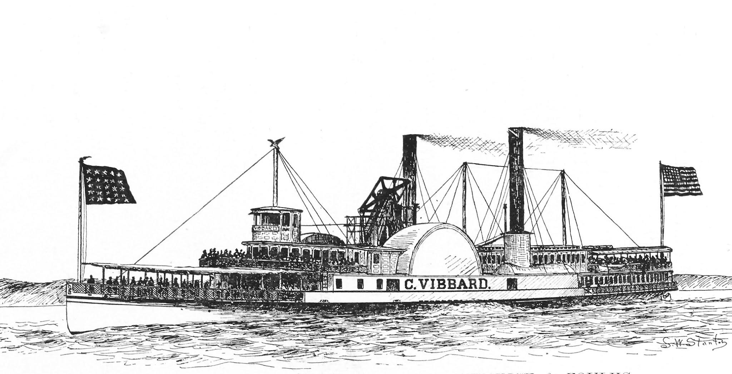

Fulton’s Steamboat - Kindergarten

**Introduction**

—----------------------------------------------------------------------------------------------------------------------------

## TELL Students

Start by asking students what some of their favorite things to play with are or what tools/devices they like to use?

These items are inventions made by creative people called innovators.

## ASK Students

* How do you think we got electronic devices, bikes, sports equipment, art supplies, and even playground equipment?
* Do you think they began as creative ideas?
* What does it mean to be creative?
* What do you think an inventor is?

## TELL Students

## Innovators are people who want to create or improve products to make life more enjoyable or convenient for themselves and others around them. Visionaries are people who have the ability to see the bigger picture and can have a big impact on people’s lives.

**WATCH**

Star Spangled Adventures Ep. 18: Fulton’s Steamboat

<please insert QR code that links to video>

Fulton’s Steamboat - Kindergarten

## **Biography Study**

—----------------------------------------------------------------------------------------------------------------------------

## **TELL** Students

There was a clever man named Robert Fulton. He wanted to be an artist. When becoming an artist was not working out for him, he became interested in making new things and solving problems.

One of the things he liked was engineering, which is when people see a problem and invent new tools or ways to solve the problem.

Robert Fulton had an idea. He wanted to make a special boat that used steam to move on the river so boats could travel faster.

He worked with his friend named Robert Livingston. They built a steamboat called, “The North River Steamboat of Clermont.”

## **WATCH**

## Learn More with Liberty Course Video on Robert Fulton:

## <https://vimeo.com/897306089?share=copy>

<please insert a QR code here that will take people to this video>

## Fulton’s Steamboat- Kindergarten

## **Clermont’s First Voyage**

## **—-------------------------------------------------------------------------------------------------------------------------------------------------------------------------------------------**

## 

## **TELL** Students

On August 17, 1807, the steamboat went on its first trip from New York City to Albany along the Hudson River. People thought it was a dangerous idea, and before the trip, some friends said it was a bad plan. But Fulton and Livingston went ahead, and even though the steamboat didn’t go very far at first, Robert Fulton got it moving.

It took the Clermont 32 hours to go from New York City to Albany. And, it was even faster on the way back! 32 hours is almost a day and a half, and was really fast back then. People were used to only using keelboats to travel these distances which were slower and very hard to move against the water’s current.

After that, the steamboat was used to carry people and things up and down the river, making life better for everyone. People paid $7 to go one-way on the steamboat. The steamboat helped America grow by moving things easily on our country’s riverways, and kick-started an industrial revolution in our country.

Fulton’s Steamboat - Kindergarten

**Vocabulary Flash Cards**

—-------------------------------------------------------------------------------------------------------------------------------------------------------------------------------------

Cut the pictures and words apart. Hold the cards up and review them with the students during a vocabulary review.

Accordion Title 1 - Inventor

* + Inventor istock image

Accordion Title 2 - Steamengine

* + <https://www.britannica.com/technology/steam-engine>
  + Please credit Hulton Archive/Getty Images

Accordion Title 3 - Steamboat

* + <https://www.britannica.com/topic/Clermont-steamboat>
  + Credit Library of Congress

Accordion Title 4 - Goods

* + <https://www.dreamstime.com/royalty-free-stock-images-farmers-market-image18351239>

Accordion Title 5 - Hudson River

* + <https://en.wikipedia.org/wiki/Hudson_River#/media/File:Hudson_river_basin_map.png>
  + Credit Wikipedia Shannon_01

Fulton’s Steamboat - Kindergarten

**Worksheet**

**—-------------------------------------------------------------------------------------------------------------------------------------------------------------------------------------------**

**Community Needs in the 1800’s**

**Recall:** In the early 1800s, the communities near the Mississippi River had a big problem with transportation. Farmers found it hard to move their food and goods up and down the river because the keelboats were pushed south by the river's currents or rowed with oars. This was really slow, and sometimes the food and goods would spoil or get stolen. Sometimes, the captains would even take the boats apart and sell the supplies.

**How did the steamboat help meet the needs of the community in the 1800’s?**

**Circle the needs of the community:**

steamboat trees birds goods

food faster travel fence mail

shelter building supplies dog cat

**Draw a picture to show how steamboats helped the communities located near rivers.**

|  |
| --- |

Fulton’s Steamboat - Kindergarten

**Resource List**

**____________________________________________________________________________**

“Studying the past makes it possible for us to understand the human story across time.”(NCSS, 1921)

“Knowledge and understanding of the past enable us to analyze the causes and consequences of events and developments and to place these in the context of the institutions, values, and beliefs of the periods in which they took place.” (NCSS, 1921)

“The study of people, places, and environments enables us to understand the relationship between human populations and the physical world.” (NCSS, 1921)

“Questions related to identity and development, which are important in psychology, sociology, and anthropology, are central to understanding who we are.” (NCSS, 1921)

“The study of individual development and identity will help students to describe factors important to the development of personal identity.” (NCSS, 1921)

1<https://www.sam.usace.army.mil/Portals/46/docs/recreation/OP->

[CO/montgomery/pdfs/10thand11th/ahistoryofsteamboats.pdf](https://www.sam.usace.army.mil/Portals/46/docs/recreation/OP-)

2 <https://education.nationalgeographic.org/resource/steamboat>

3 <http://www.southernlancasterhistory.org/robert-fulton-birthplace>

4 <https://www.pbs.org/wgbh/theymadeamerica/whomade/fulton_hi.html>

5 <http://www.southernlancasterhistory.org/robert-fulton-birthplace>

6 <https://lemelson.mit.edu/resources/robert-fulton>

7 <https://www.pbs.org/wgbh/theymadeamerica/whomade/fulton_hi.html>

8 <https://www.sam.usace.army.mil/Portals/46/docs/recreation/OP->

[CO/montgomery/pdfs/10thand11th/ahistoryofsteamboats.pdf](https://www.sam.usace.army.mil/Portals/46/docs/recreation/OP-)

9 <https://lemelson.mit.edu/resources/robert-fulton>

10<https://www.nytimes.com/1987/11/17/opinion/l-why-fulton-achieved-steamboat-success-003087.html>

11 <http://www.southernlancasterhistory.org/robert-fulton-birthplace>

12 <https://lemelson.mit.edu/resources/robert-fulton>

13<https://www.nytimes.com/1987/11/17/opinion/l-why-fulton-achieved-steamboat-success-003087.html>

14 <https://www.sam.usace.army.mil/Portals/46/docs/recreation/OP->

[CO/montgomery/pdfs/10thand11th/ahistoryofsteamboats.pdf](https://www.sam.usace.army.mil/Portals/46/docs/recreation/OP-)

15 <http://www.eyewitnesstohistory.com/fulton.htm>

16<https://education.nationalgeographic.org/resource/steamboat>

17<https://lemelson.mit.edu/resources/robert-fulton>

18<https://www.sam.usace.army.mil/Portals/46/docs/recreation/OP->

[CO/montgomery/pdfs/10thand11th/ahistoryofsteamboats.pdf](https://www.sam.usace.army.mil/Portals/46/docs/recreation/OP-)

**Notes**