***First Grade***

**DISCOVER AMERICA**

Course 18 - Teacher Guide

<please insert text overlay on photo that says: Fulton’s Steamboat>

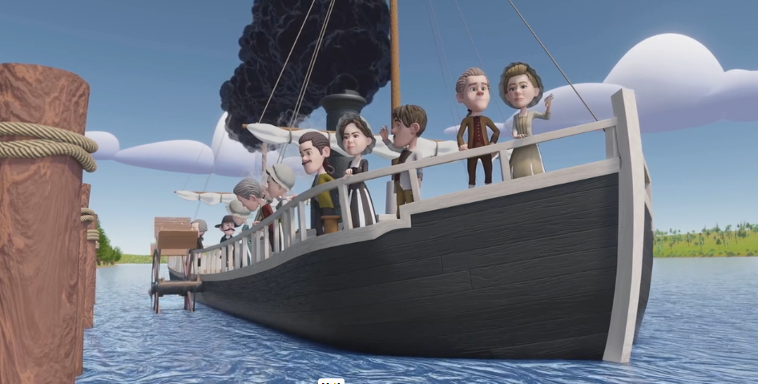

# Table of

**Contents**

# **3 Themes & Values**

# **4 Learning Objectives**

# **5 Key Terms**

# **6 Introduction**

# **7 Steamboat Fast Facts**

# **8 Robert Fulton Review**

# **9 Activity**

**11 Resources**

**13 Notes**

***First Grade***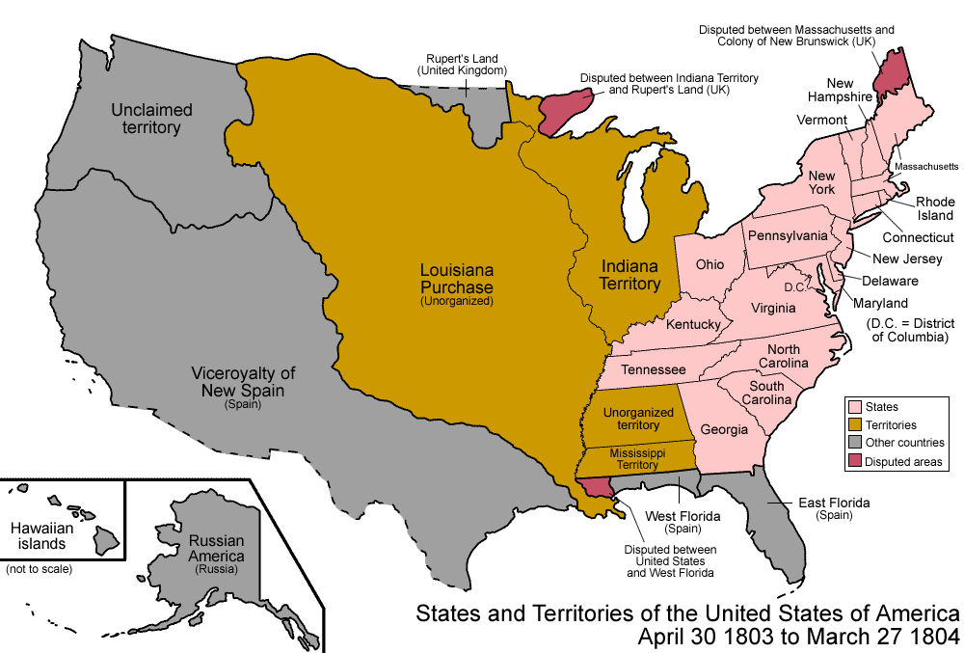

# ***Teacher***

# ***Guide***

# **Key Themes**

* Creative freedom
* Community
* Experimentation

# **Core Values**

* Community
* Liberty

# **Learning Objectives**

# **Students will be able to:**

* Define creativity.
* Identify the importance of a community.
* Understand the purpose of a steamboat and how it changed transportation in America.

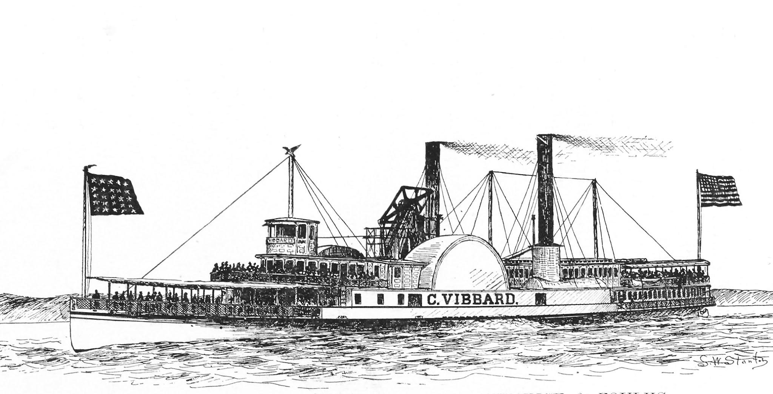

Fulton’s Steamboat - First Grade

# **Key Terms**

01 **inventor:** aperson who creates a

process or device to improve

circumstances.

02 **visionary:** a person who creatively thinks about the future.

03 **river transportation:** a boat or ship

that moves up and down a river.

04 **efficient:** working in a well-organized

way.

05 **steam engine:** an engine that uses steam to generate power.

07 **innovation:** a new method, idea, or

product that helps the community.

08 **community:** a group living in an

area with similar interests, beliefs,

attitudes, and goals.

Fulton’s Steamboat - First Grade

**Introduction**

**—---------------------------------------------------------------------------------------------------------------------------------------------------------------------------**

## 

## **TELL** Students

Have you ever been in a lake, pool, or ocean and felt the water moving quickly? It can be hard to move easily or swim against quickly moving water.

A long time ago, people in communities lived near big rivers; two you may have heard of are the Mississippi River and Hudson River. Communities needed a way to move things from one place to another. River transportation was the best option but it was really hard because the river's strong current pushed their boats the wrong way. People then had to use oars to row the boat the direction they wanted it to go, which was slow.

An engineer and inventor named Robert Fulton came up with a way to make steamboat travel successful by creating a boat that used a steam engine to power it.

The steamboat would transform transportation by making it more efficient for people to travel and transport goods up and down America’s rivers.

**WATCH**

Star Spangled Adventures Cartoon Ep. 18: Fulton’s Steamboat

**<please insert video QR code>**

Fulton’s Steamboat - First Grade

**Steamboat Fast Facts**

**—---------------------------------------------------------------------------------------------------------------------------------------------------------------------------**

**TELL** Students

* + Fact One
  + The first successful steamboat was named “The North River Steamboat of Clermont.”

Fact Two

* + The steamboat’s first voyage was along the Hudson River from New York City to Albany, New York.

Fact Three

* + The Clermont’s first voyage took 32 hours.

Fact Four

* + After its first successful voyage, people paid $7 to ride on the steamboat.

Fact Five

* + The steamboat helped America grow by making it easier to travel and transport goods.

**WATCH** Video Recap

Learn More with Liberty Course Video: What Is A Steamboat?

<https://vimeo.com/897305811?share=copy>

(insert QR code to video)

Fulton’s Steamboat - First Grade

**Robert Fulton Review**

**________________________________________________________________________________________________________________________**

## 

## **TELL** Students

Robert Fulton was born in Pennsylvania. He started his creative career as an artist, painting beautiful pictures. He even went to London to study art. But he didn't become as famous as he wanted to be in the art world. Robert was a very creative person who didn't give up easily. He started to become interested in other things, like engineering. He designed canals, big ships, and even made the first submarine called the Nautilus. Then, he worked with a man named Robert Livingston on a brand-new invention that would change our country– the first successful steamboat!

**WATCH** Recap & Learn More

Learn More with Liberty Course Video: Robert Fulton

<https://vimeo.com/897306089?share=copy>

**TELL** Students

Robert Fulton was a visionary. A visionary is a creative person who thinks about the future and how they can change or invent items to help people. Robert Fulton was also an ambitious person. When his art career did not work out, he did not let this discourage him. Instead, Robert Fulton applied his passion for drawing and creating to machinery and transportation– and his inventions changed the transportation industry and communities.

Fulton’s Steamboat - First Grade

**Activity**

—-------------------------------------------------------------------------------------------------------------------------------------------------------------------------------------

**Create A Steamboat**

Place the following items in a box: string, color pencils, tooth picks, glue, water color paint, rubber bands, buttons, and crayons. Ask students to be creative. Ask students to use innovation to change the materials in the box into a steamboat.

Example: 

List the items that you want to use to create your steamboat:

_________________________________________________________

_________________________________________________________

My image of a steamboat:



Why did you choose the materials you used?

Why is it important to be creative?

In some countries people do not have the freedom to express their creativity. Why is freedom an important part of being creative?

Fulton’s Steamboat - First Grade

**Resource List**

**_________________________________________________________________________**

**National Council Standards for Social Studies**

“Studying the past makes it possible for us to understand the human story across time.”(NCSS, 1921)

“Knowledge and understanding of the past enable us to analyze the causes and consequences of events and developments and to place these in the context of the institutions, values, and beliefs of the periods in which they took place.” (NCSS, 1921)

“The study of people, places, and environments enables us to understand the relationship between human populations and the physical world.” (NCSS, 1921)

“Questions related to identity and development, which are important in psychology, sociology, and anthropology, are central to understanding who we are.” (NCSS, 1921)

“The study of individual development and identity will help students to describe factors important to the development of personal identity.” (NCSS, 1921)

1<https://www.sam.usace.army.mil/Portals/46/docs/recreation/OP->

[CO/montgomery/pdfs/10thand11th/ahistoryofsteamboats.pdf](https://www.sam.usace.army.mil/Portals/46/docs/recreation/OP-)

2 <https://education.nationalgeographic.org/resource/steamboat>

3 <http://www.southernlancasterhistory.org/robert-fulton-birthplace>

4 <https://www.pbs.org/wgbh/theymadeamerica/whomade/fulton_hi.html>

5 <http://www.southernlancasterhistory.org/robert-fulton-birthplace>

6 <https://lemelson.mit.edu/resources/robert-fulton>

7 <https://www.pbs.org/wgbh/theymadeamerica/whomade/fulton_hi.html>

8 <https://www.sam.usace.army.mil/Portals/46/docs/recreation/OP->

[CO/montgomery/pdfs/10thand11th/ahistoryofsteamboats.pdf](https://www.sam.usace.army.mil/Portals/46/docs/recreation/OP-)

9 <https://lemelson.mit.edu/resources/robert-fulton>

10<https://www.nytimes.com/1987/11/17/opinion/l-why-fulton-achieved-steamboat-success-003087.html>

11 <http://www.southernlancasterhistory.org/robert-fulton-birthplace>

12 <https://lemelson.mit.edu/resources/robert-fulton>

13<https://www.nytimes.com/1987/11/17/opinion/l-why-fulton-achieved-steamboat-success-003087.html>

14 <https://www.sam.usace.army.mil/Portals/46/docs/recreation/OP->

[CO/montgomery/pdfs/10thand11th/ahistoryofsteamboats.pdf](https://www.sam.usace.army.mil/Portals/46/docs/recreation/OP-)

15 <http://www.eyewitnesstohistory.com/fulton.htm>

16<https://education.nationalgeographic.org/resource/steamboat>

17<https://lemelson.mit.edu/resources/robert-fulton>

18<https://www.sam.usace.army.mil/Portals/46/docs/recreation/OP->

[CO/montgomery/pdfs/10thand11th/ahistoryofsteamboats.pdf](https://www.sam.usace.army.mil/Portals/46/docs/recreation/OP-)

**Notes**